**Cover Page**



Date: 05/12/2020

Certiﬁcate

This is to certify that Mr. Sourav Agrawal, Mr. Sahil Mansuri, Mr.Divyansh Jain from the Department of Computer Sciences, St. Xavier’s College (Autonomous) of BCA Semester-V have successfully completed their project work as a trainee for the current semester of the academic year 2020-2021, for the project titled “Online Food Ordering System”.

As part of the project, till now they have completed following tasks under our company guidance:

* Required analysis for their Project
* DFD/UML
* ERD
* Data Dictionary

During the project work they were found sincere and cooperative.

We admire their enthusiasm and involvement in the project and hope that they will show the same enthusiasm in the coming semester

Jugal Prajapati

Project Manager

**INDEX**

**SR. NO. TOPICS Page No.**

1. ACKNOWLEDGEMENT……………………………………………………………………..5

2. INTRODUCTION……………………………………………………………………………..6

3. ORGANIZATION PROFILE…………………………………………….…………………...7

4. PROJECT PROFILE

4.1 EXISTINGSYSTEM…………………………………………………………………..…8

4.2 PROPOSED SYSTEM………………………………………………………………….10

4.3 DEVELOPMENT TOOLS AND TECHONOLOGIES USED…………………………11

5. DATA FLOW DIAGRAM

5.1 CONTEXLEVEL………………….……………………………………………………..12

5.2 LEVEL1…………………………………………………………………………………….13

5.3 LEVEL 2

5.3.1 LOGIN………………………………………………………………………………..14

5.3.2CATEGORY……………………………………………………..…………………....15

5.3.3 FOOD ITEM…….……………………………………………………………….…...16

5.3.4 ORDER…………………………………………………..……………………………… .17

5.3.5 PAYMENT…………………….…………………………………..……………………....18

5.3.6 DELIVERY….……………………………………………..………….……….………….19

5.3.7 FEEDBACK..……………………………………………..………….……………………20

6. ENTITY RELATIONSHIP DIAGRAM……………………………………………………..21

7. DATA DICTIONARY……………………………………………………………………....22

8. BIBLIOGRAPHY……………………………………………………………………………26

**Acknowledgement**

Any project, simple or complex is successful largely due to the collective and individual efforts of a number of people who have given their valuable time and advice or lent a helping hand whenever necessary. It has been privilege to meet new people and have new experience and to learn from it all. We sincerely appreciate the motivation, support and inspiration given by all those people whose guidance has been essential and helpful in making this project a success. First and the foremost we would like to thank Dr. (Fr.)JohnsonMundupuzhakal Vice Principal(SF Courses) for giving us this opportunity to learn and provide us with facilities to complete the project. We concern ourselves lucky to have been exposed to the world of Artificial Intelligence.

We, Divyansh Jain, Sahil Mansuri and Sourav Agrawal, the students of St. Xavier’s College (Autonomous), are extremely grateful to “Aarnik Technology” for confidently entrusting us with the responsibility of the development and partial completion of the project “Online Food Ordering System” and convey our gratitude for the generous assistance and cooperation, that we received from Mr Jugal Prajapati our External Guide for making sure that the right resources were available to us at the right time and for providing his valuable insights and guidance.

We am sincerely thankful to our Internal Guide, Ms. Manali Bhrambhatt for her constant help, stimulating suggestions and encouragement helped us in completing various phases of our project.

We would also like to heartily thank all the faculty members of Department of Computer Sciences, St. Xavier’s College (Autonomous) for their timely advice and guidance without which this project would not have been possible.

Last but not the least, we also place our deep sense of gratitude to our family members and our friends who have been a constant source of inspiration and motivation during the completion of this project work so far.

**1. Introduction**

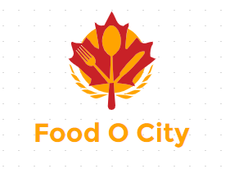

Our project is primarily a food ordering and delivering service offered online through the use of website and web application.

The Online Food Ordering System is a food ordering website which provides convenience to the customers by providing online ordering system and overcomes disadvantages of the traditional queuing systems.

It gives restaurants the ability to increase their sales and expand their business.

With Online Food Ordering system, we can setup restaurant menu online and customers can also track their orders with few simple steps.

There are three main entities in our project

* Admin
* Restaurants
* Customers

**2. Organization Profile**

**E:\Study\SEM 5\PROJECT\Presentation\Aarniklogofinal.png**

**Aarnik Technology**

Aarnik Technology, as a website development company, holds a reputed image among its competition. Thecompany believes on developing completely unique and outstanding websites.

Aarnik Technology has always assured the best services to its clients as it has professionals working for its clients.It excels in fields like website development, mobile app development, digital marketing, and ERP software development.

**Company Details:**

**Company Name** :Aarnik Technology

**Address** : K8 Krishna Centre, Navrangpura, Ahmedabad 380009

**Email Address** :[info@aarniktechnology.com](mailto:info@aarniktechnology.com)

**Contact Number** : 9586248516

**3.Project Profile**

**3.1 Existing System**

In the old manual systems, there were series of drawbacks, as the whole system was maintained by humans. The processes consisting of keeping, maintaining and retrieving the data were very time consuming.

Records were never easily stored in sorted order and hence problems kept arising at the time of data retrieval.Detecting errors in the data was also a big problem for restaurants with a large customer base and high frequency of orders.

Generation of reports was not easy for financial planning, as there would rise problems such as data redundancy and incomplete data.

In the light of current pandemic, it is a saferoption to order food from a food ordering website, rather than visiting the restaurant physically.Because you never know, who has already been there.

**Requirement Gathering**

What we have come up with is, an online food ordering system which is completely web-based. This system can be a proven solution in today’s modern world where people live a busy life.

In this system, admin can approve restaurant users to register on the website to accept orders, payment details and can also generate reports.

The restaurants can manage food items, accept orders, create menu categories, they can accept payments using the website.

Today inflation rates are increasing rapidly, so in such time to have afine dining experience at the restaurant is not feasible for everyone. This way people can have their favourite food delivered at their home.

**3.2 Proposed System**

In some of the existing systems, Users must have a physical menu to order their food over a telephonic communication,this can often result into misunderstanding due to unclear communication through telephones.

What we propose is, a website-based online food ordering system which can ease the problems of almost all users connected to it.

Using the Online Food Ordering System, users can order food through the website without standing in lines in front of the restaurant.

The users can manage their cart and can place orders from their carts, they can also track the delivery status of their orders, and they can make payments using the website.

This system helps restaurants to manage all information regarding orders, their customers, payment related activities and feedbacks on a central server, the information can be retrieved as and when required.

To improve the user’s experience, the system also allows users to search based on names of dishes, and restaurants.

**3.3 Development Tools and Technology**

**Frontend** :HTML, CSS, Python,Django v3.1

**Backend Database**: MySQL v5.6

**Other Tools**: Edraw Max 9.0, Microsoft PowerPoint 2010, Microsoft Word 2010

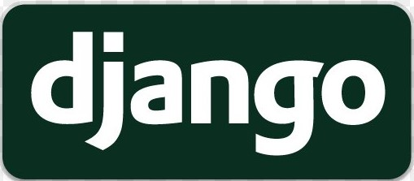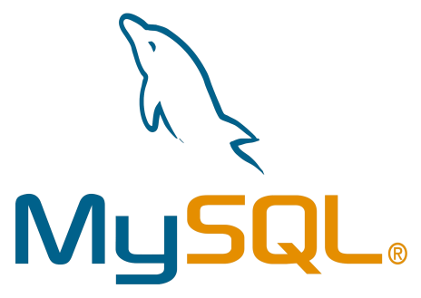





**4.Data Flow Diagrams**

**4.1 Context Level Diagram**

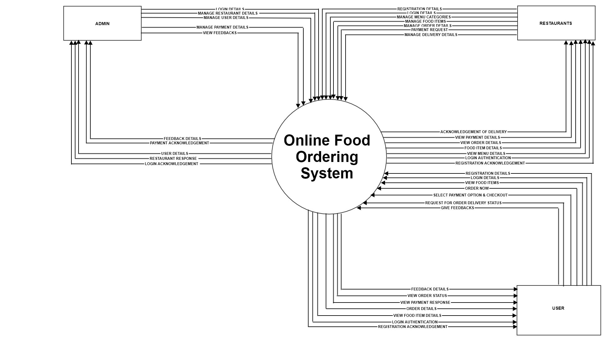

**4.2 Level 1 Dataflow Diagram**

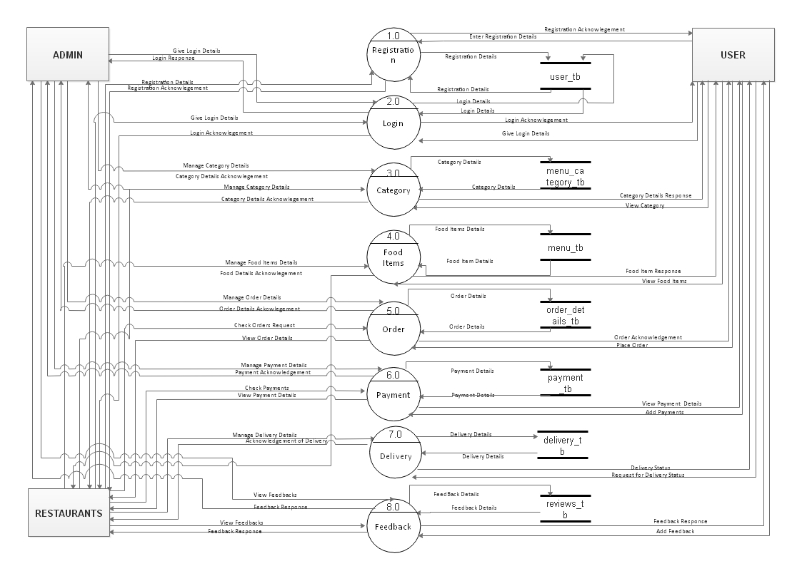

**4.3 Level 2 Dataflow Diagram**

**(Login)**

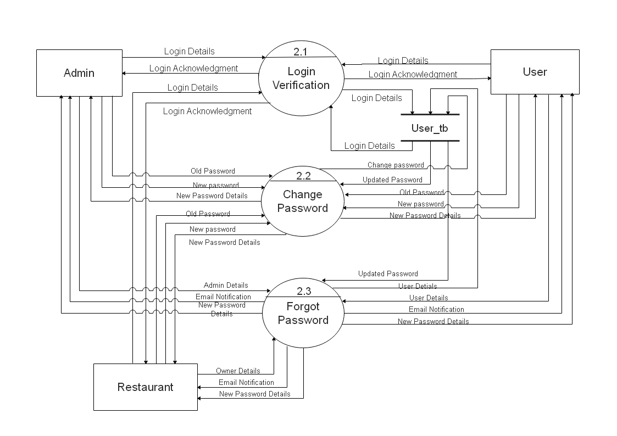

**(Category)**

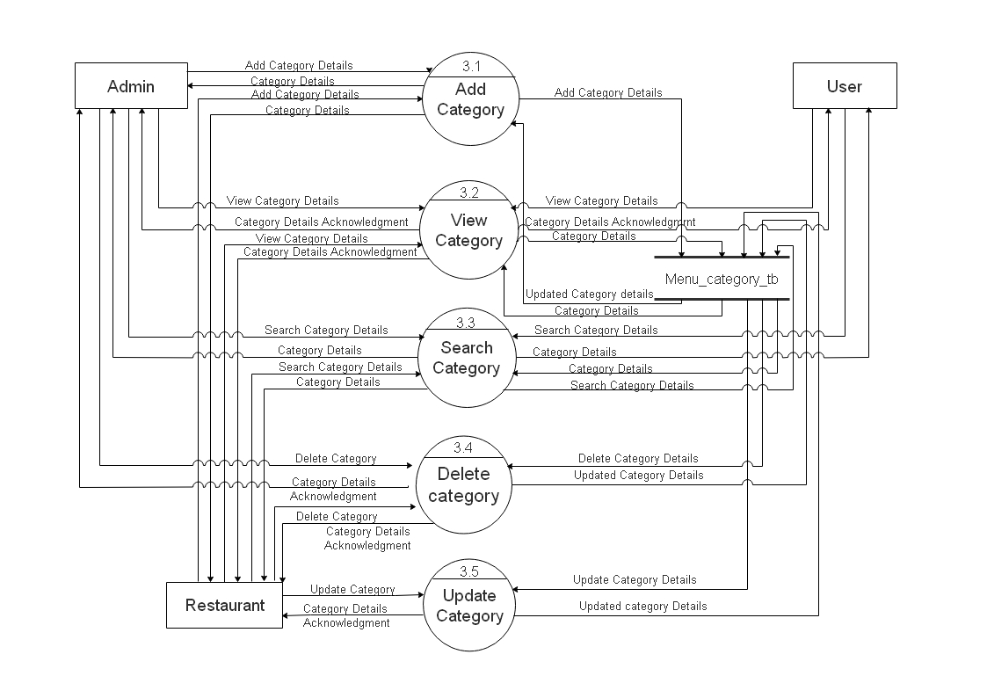

**(Food Item)**

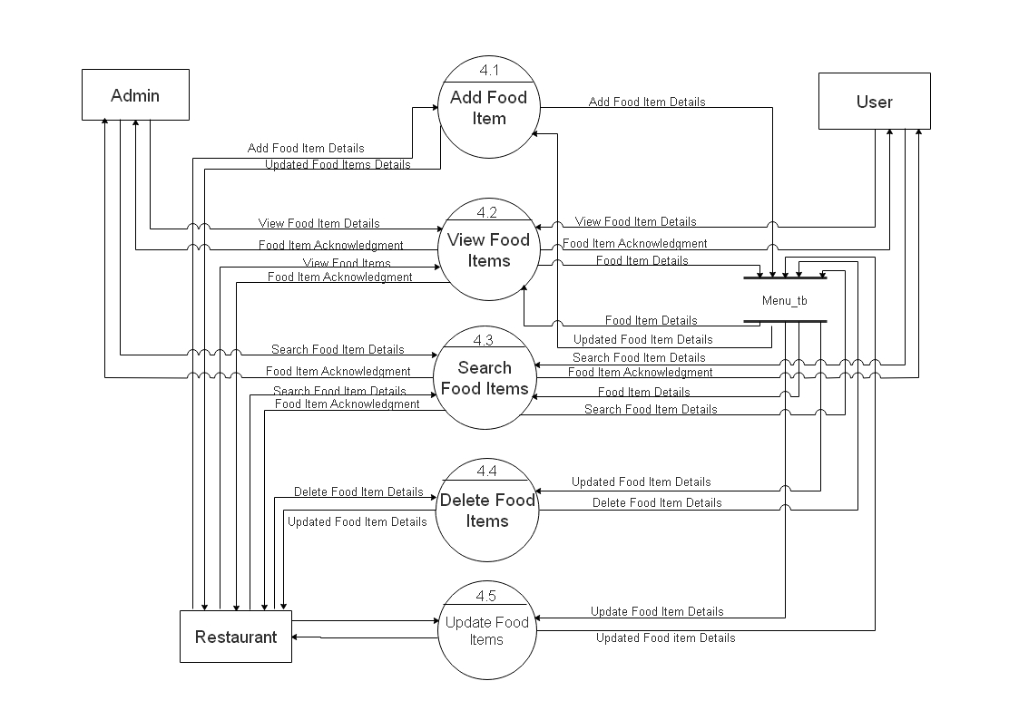

**(Order)**

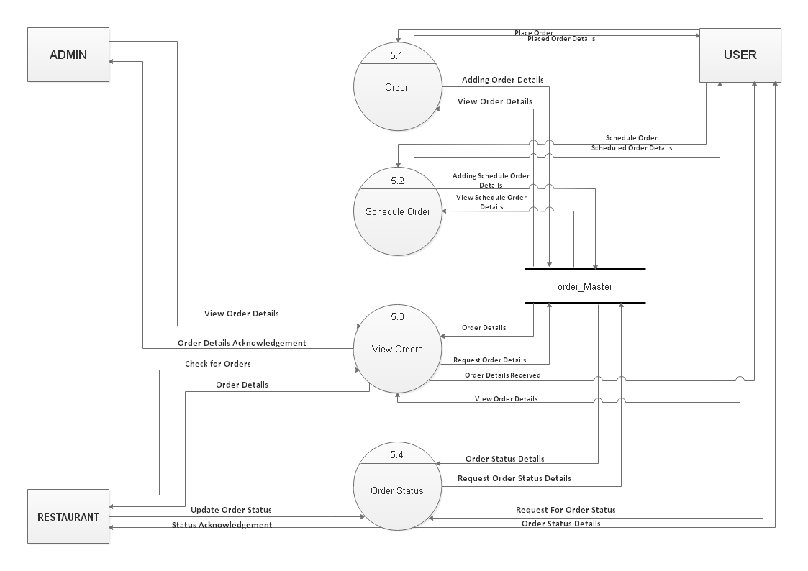

**(Payment)**

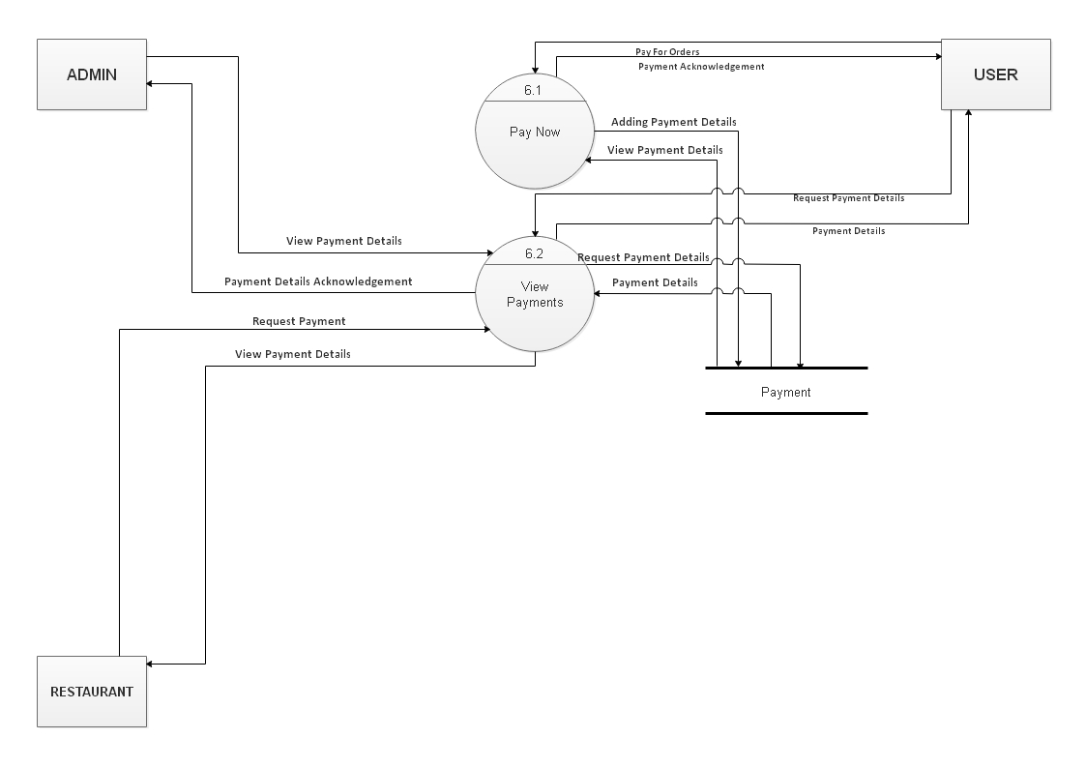

**(Delivery)**

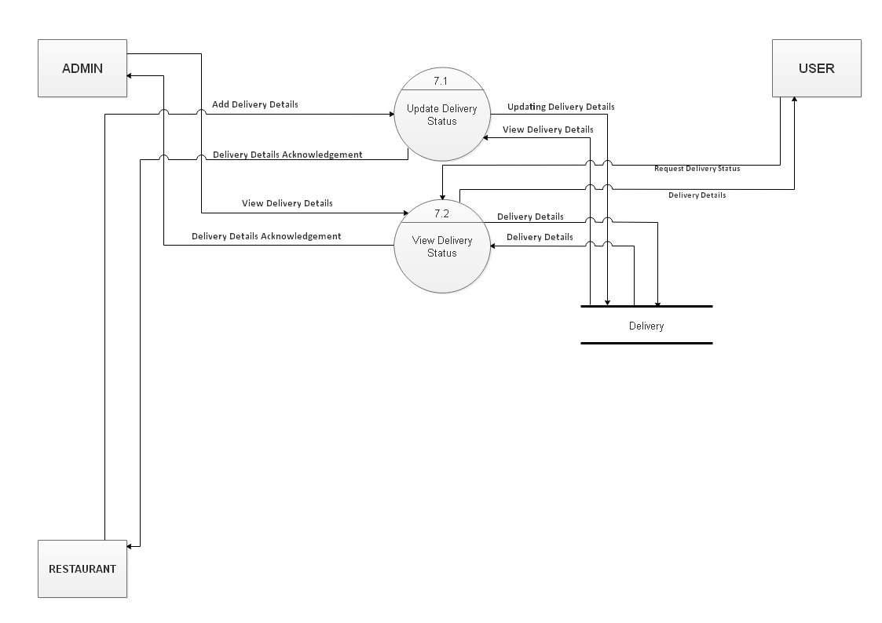

**(Feedback)**

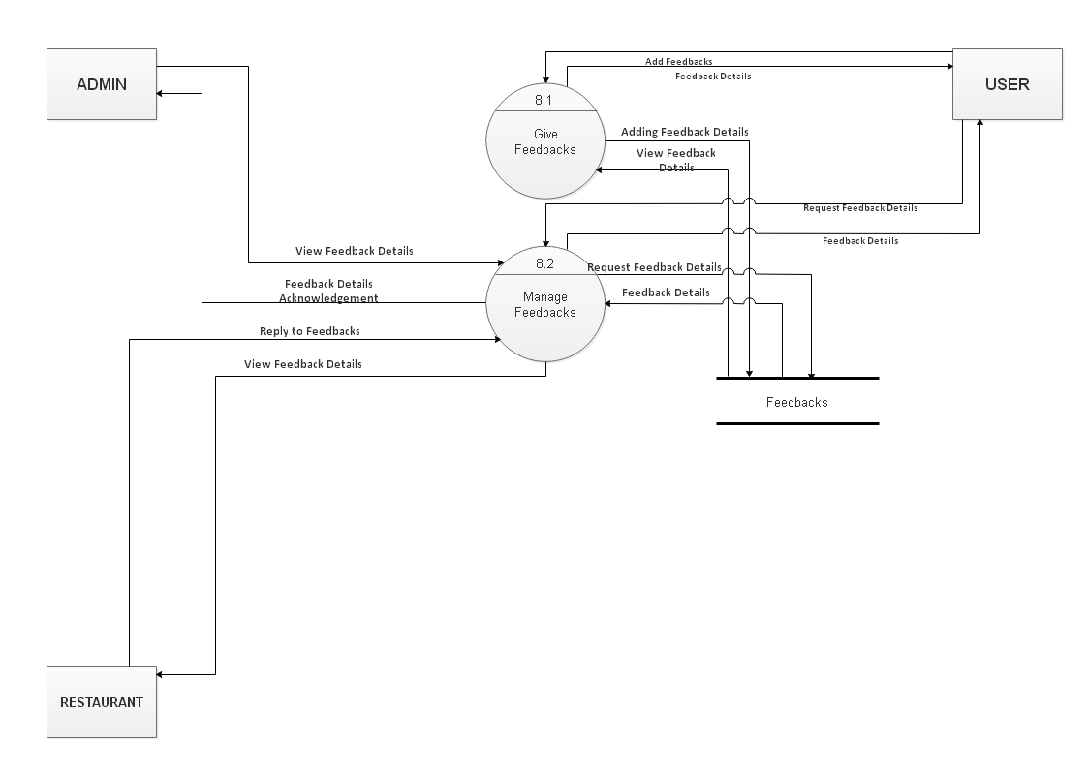

**6.ERD (Entity Relationship Diagram)**

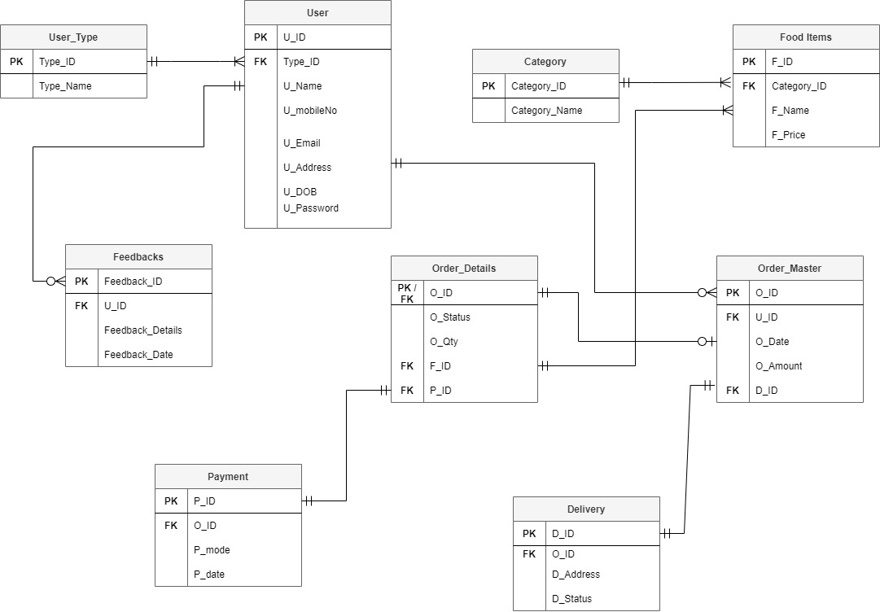

**7.Data Dictionary**

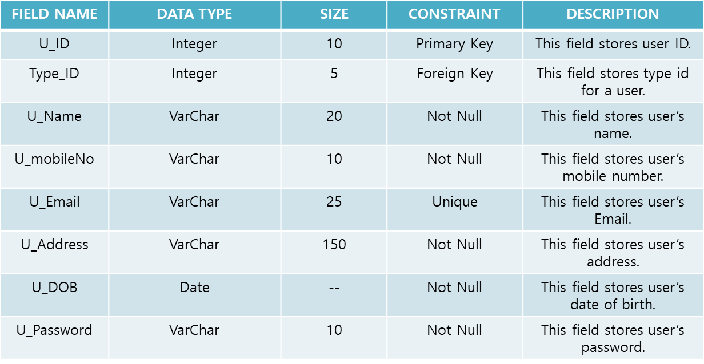

**Description:** This table stores all the details regarding users in the system

**Table Name: User**

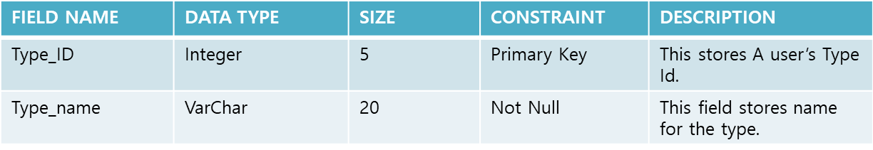

**Table Name:user_type**

**Description:** This table stores the user’s type.

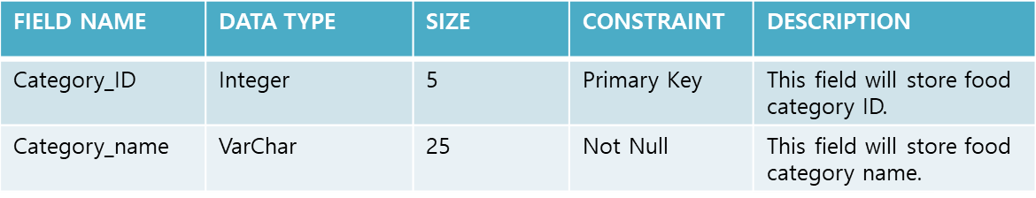

**Table Name: category**

**Description:** This table will store category details for the menu.

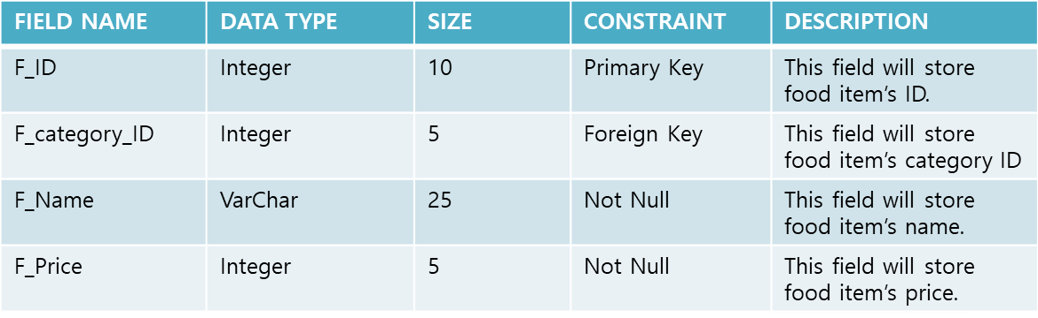

**Table Name:Food_Items**

**Description:** This table will store details of Food Items

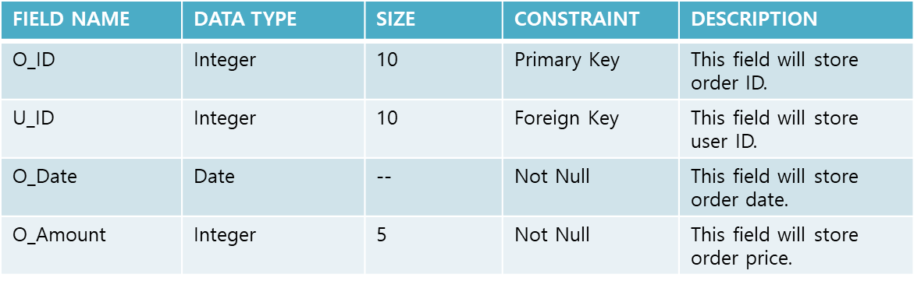

**Table Name: Order_Master**

**Description:** This table will store necessary information of orders.

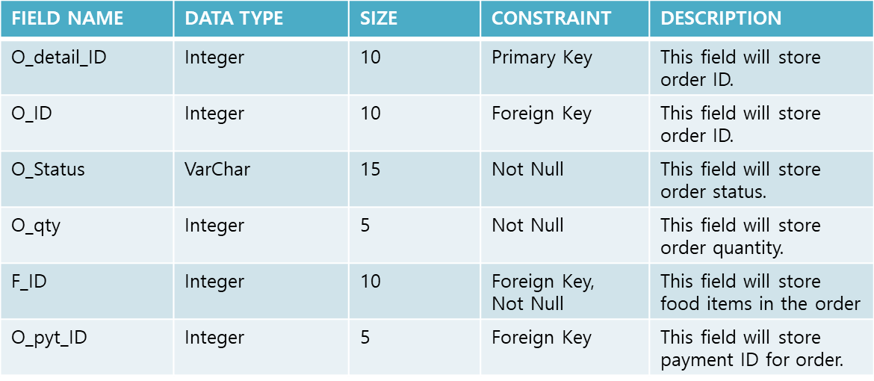

**Table Name:Order_Details**

**Description:**This table will store all details of orders.

**Table Name: Payment**

**Description**:This table will store information regarding Payment

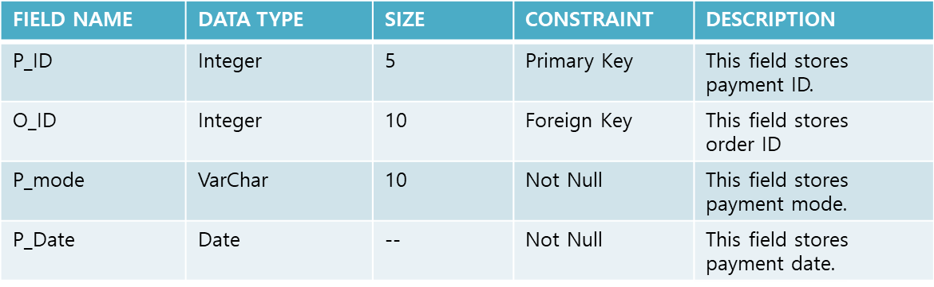

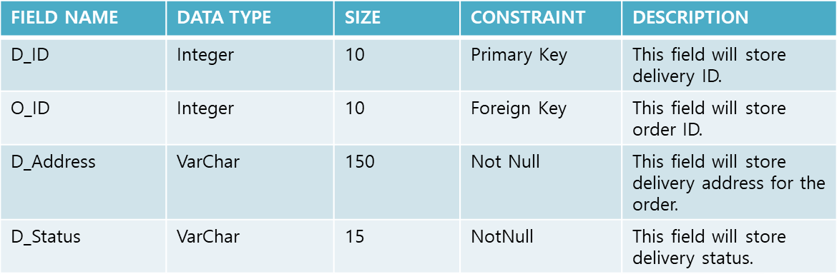

**Table Name: Delivery**

**Description:** This table stores data for delivery details.

**Table Name: Feedbacks**

**Description:** This table will include data about feedback details

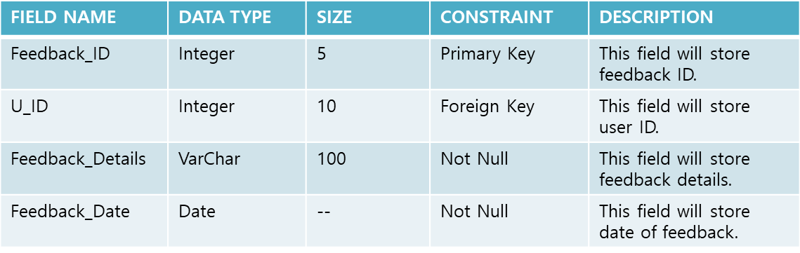

**Bibliography**

The following resources were used during the execution of our project.

<https://www.djangoproject.com/start/>

<https://www.tutorialspoint.com/django/index.htm>

<https://www.geeksforgeeks.org/django-tutorial/>

<https://realpython.com/tutorials/django/>

<https://www.freepik.com>

<https://fonts.google.com/>